MINI PROJECT ON ROBOTICS/AUTOMATION PROPOSAL
Project: IoT in robotics and automation
Submitted By: Goka Harshini Sai
Internship Organization: CodeAlpha
Domain: Robotics and Automation
Submitted in partial fulfillment of the requirements for the CodeAlpha internship program
College Name: Sri Devi Women’s Engineering College
Department: Artificial Intelligence and Machine Learning
Internship Duration: 10th June 2026 – 10th July 2026
Submission Date: 12th June 2026

Abstract
This project focuses on IoT in robotics and automation, where sensors and microcontrollers are used to collect and process real-time data. The system enables remote monitoring and control of robotic movements through the internet. IoT technology helps improve efficiency, accuracy, and automation by reducing human effort. This integration is useful in applications like smart industries, agriculture, and surveillance systems, making robots more intelligent and connected.

Introduction
The Internet of Things (IoT) in robotics and automation is a technology that connects robots to the internet for smart control and monitoring. It allows robots to collect data using sensors and send it to a system or cloud for processing. Based on this data, robots can perform tasks automatically or be controlled remotely.
This technology improves efficiency, accuracy, and reduces human effort in various fields. IoT-based robotics is widely used in industries, agriculture, healthcare, and security systems. It helps in building smart and automated systems that can work more effectively with minimal human intervention.
Objectives
- Understand the concepts of IoT and Robotics.
- To develop a system that connects sensors and microcontrollers for real-time data collection.
- To improve efficiency, accuracy, and automation in performing tasks

System Architecture
The IoT-based robotics and automation system consists of sensors, a microcontroller, a communication module, and a user interface. Sensors collect real-time data from the environment and send it to the microcontroller for processing. The microcontroller analyzes the data and sends it through Wi-Fi or Bluetooth to a cloud or web platform. The user can monitor and control the robot through this interface. Finally, actuators or motors perform the required actions based on the received commands, making the system automated and smart.
Temperature Sensor (Simulated) → Node.js Server → Data Processing → Web Dashboard → Alert System

Working of the System
The system generates random temperature values between 20°C and 40°C every two seconds. Based on the value, the dashboard displays Normal, Low Temperature, or High Temperature Alert. This demonstrates IoT monitoring and automation concepts.
The generated data is continuously updated in real time, simulating how IoT sensors send live information to a monitoring system. The microcontroller or server processes each new value and immediately evaluates the condition, ensuring instant response without delay. This helps in understanding how real-world IoT systems work with continuous data flow.
The dashboard acts as the user interface, where the status is displayed clearly for monitoring purposes. If the temperature remains within the normal range, it shows a stable condition, while any deviation triggers alerts. This simple setup demonstrates how automation systems can monitor environments and support quick decision-making in smart applications.
Technologies Used
Node.js, HTTP Module, HTML, CSS, JavaScript, and Visual Studio Code.

Complete Source Code
const http = require("http");

let temperature = 25;

// Simulate sensor data changing every 2 seconds
setInterval(() => {
temperature = Math.floor(20 + Math.random() * 20);
// range: 20°C to 40°C
}, 2000);

const server = http.createServer((req, res) => {

let status = "NORMAL";
let color = "#22c55e";

if (temperature > 35) {
status = "HIGH TEMPERATURE ALERT!";
color = "#ef4444";
} else if (temperature < 25) {
status = "LOW TEMPERATURE";
color = "#3b82f6";
}

res.writeHead(200, { "Content-Type": "text/html" });

res.write(`
<html>
<head>
<title>IoT Sensor Dashboard</title>

<style>
body {
font-family: Arial;
background: #0f172a;
color: white;
text-align: center;
}

.card {
margin-top: 80px;
background: #1e293b;
width: 350px;
margin-left: auto;
margin-right: auto;
padding: 25px;
border-radius: 15px;
box-shadow: 0px 0px 20px #38bdf8;
}

.temp {
font-size: 50px;
margin: 20px;
color: #facc15;
}

.status {
font-size: 20px;
color: ${color};
font-weight: bold;
}

.note {
margin-top: 15px;
font-size: 14px;
color: #94a3b8;
}
</style>
</head>

<body>

<h1>🌡️ Smart IoT Sensor Monitoring System</h1>

<div class="card">

<h2>Live Temperature Sensor</h2>

<div class="temp">
${temperature} °C
</div>

<div class="status">
${status}
</div>

<div class="note">
Data updates automatically every 2 seconds (simulated IoT sensor)
</div>

</div>

</body>
</html>
`);

res.end();
});

server.listen(3000, () => {
console.log("IoT Sensor Dashboard running at http://localhost:3000");
});

Results and Applications
The system successfully simulates a real-time IoT temperature monitoring environment by generating random values between 20°C and 40°C every 2 seconds.
The dashboard correctly displays the live temperature readings with continuous updates.
Based on the temperature value, the system accurately classifies the condition as Low Temperature, Normal, or High Temperature Alert.
It can be used in smart homes for automatic temperature monitoring and device control like fans or ACs. In industries, it helps in monitoring machine conditions and improving safety through alerts.
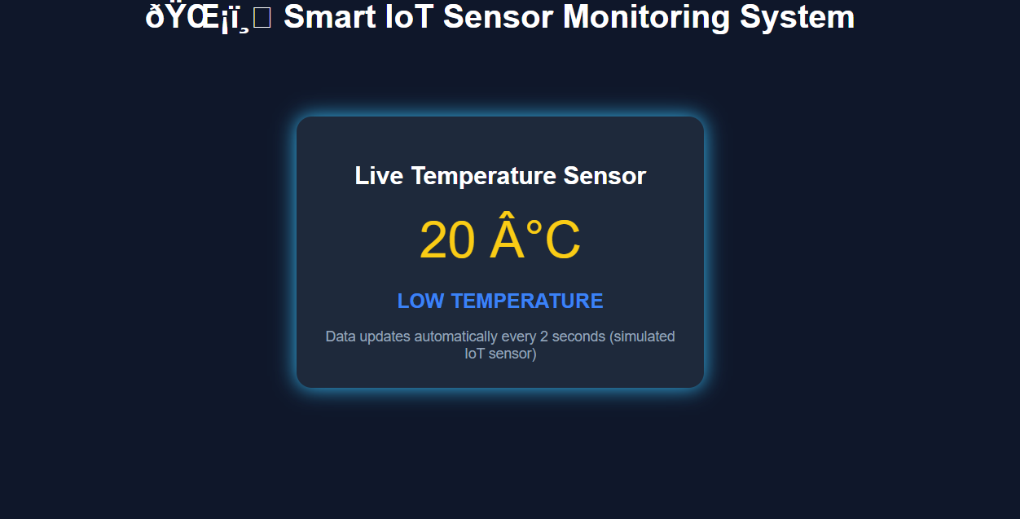

Advantages
• Real-time monitoring
• Easy implementation
• Low cost
• Scalable architecture
• Supports automation
Future Scope
In the future, this IoT-based robotics system can be improved by adding AI and automatic control features to take actions without human intervention. It can also be expanded by connecting multiple sensors and using cloud platforms for real-time monitoring and data storage. This will make the system more smart, efficient, and useful for applications like smart homes, industries, and agriculture.

Conclusion
The project demonstrates how IoT can be used for monitoring and automation in robotics. By simulating sensor data and generating alerts, the system showcases key IoT concepts in a simple and effective manner.

References
1. Node.js Documentation
2. Cisco IoT Fundamentals
3. IEEE Internet of Things Journal

